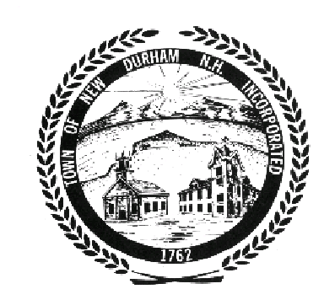

ETHICS COMMITTEE

PUBLIC MEETING AGENDA
August 11th, 2009

*******************************************

Place: Upper Conference Room in the Town Hall
Time: 6:30 PM

***************************************************************************************************

I. ADMINISTRATIVE
- Call to Order

II. APPROVAL OF MINUTES
- Minutes of July 14th, 2009

III. OLD BUSINESS
- Mock trial complaint enactment

IV. ANY OTHER BUSINESS

V. ADJOURNMENT

The Ethics Committee may enter into Non Public Session, if so voted,
Under the terms and conditions of RSA 91-A:3 II a ~ e and RSA 91-A: 2 I c.

